Handleiding importeren Toets in Smart Response systeem.

Multiple Choice vragen importeren uit word en invoegen in Notebook.
Klik op het Smart-Response-icoontje op de taakbalk onder op je bureaublad 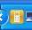

Kies voor Notebook-software openen

Klik op het menu response
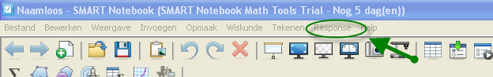

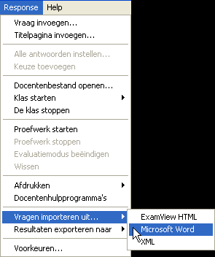
en kies voor Vragen importeren uit word.
Zorg ervoor dat de vragen in Word, gemaakt zijn met de automatische nummer opmaak, anders herkent de notebooksoftware de vragen niet als MC vragen.

Voeg de antwoorden toe en sla het notebook - Smart response bestand op.

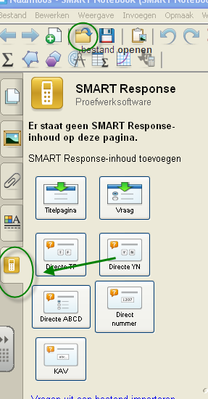
Klik in het linkermenu op het tabblad Smart-response en daarna op bestand openen.
Zoek het Smart –reponse bestand en open het.

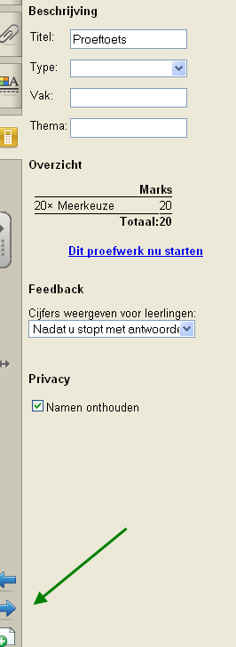
Stel de toets in
Klik op de blauwe pijl onder in het linker menu en ga naar vraag 1

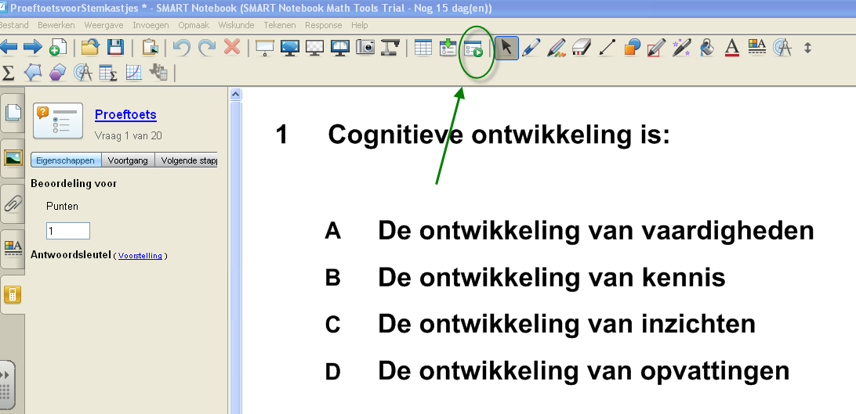Klik in het bovenste menu op proefwerk starten
Nu kun je een anonieme toets afnemen.

SMART Response Help
Starting a Class and Connecting Clickers > Starting a Class >

Starting a Class in Anonymous Mode
You don't need a class list to operate SMART Response in Anonymous mode. This table provides more information on the difference between Anonymous and Sign In modes.

To start a class in Anonymous mode
- Click the SMART Response icon in the Windows notification area or Mac menu bar, and then select the icon below the Teacher Tools heading.
- If Teacher Tools opens in Basic view, click Start a Class, and then select Anonymous Mode from the drop-down list.
OR
If Teacher Tools opens in Gradebook view, select Anonymous Mode in the Gradebook area on the left, and then click Start Class.
The receiver’s power LED light flashes and then turns solid green, and the receiver's Transmit LED light flashes green. You can now ask the students to turn on and connect their clickers.
NOTES
- If the students have already signed in to a class, and you select Anonymous Mode, the clickers switch to Anonymous mode.
- If the clickers are in Anonymous mode, and you start a class that requires sign-in, the clickers sign off and then ask the students to sign in.

Starting a Class in Sign In Mode
NOTE: Before you can start a SMART Response class and have students connect in Sign In mode, you must have a class list. If you don't have a class list, you can create or import class lists.

To start a class in Sign In mode
- Click the SMART Response icon in the Windows notification area or Mac menu bar, and then select the icon below the Teacher Tools heading.
- If Teacher Tools opens in Basic view, click the Start a Class button, and then select the class from the drop-down list.
OR
If Teacher Tools opens in Gradebook view, select the class in the Gradebook area on the left, and then click Start Class.
The receiver's Power LED light flashes and then turns solid green, and the receiver’s Transmit LED light flashes green. You can now ask the students to turn on and connect their clickers.

Om een toets op naam af te nemen en de resultaten te bewaren , volg onderstaande handleiding
http://www.smartboard.nl/Static/Documents/UserUpload/producten/response/Response-Korte-Handleiding-instellen.pdf

